Joshua Williamson
CS370
October 6th 2026

Module 6-2 Cartpole Revisited

CartPole Revisited
The CartPole problem requires an agent to keep a pole balanced on a moving cart by choosing to move either left or right. The agent observes the cart position, cart velocity, pole angle, and pole velocity to determine its actions. While the Deep Q-Network can solve CartPole using a value-based approach, REINFORCE and A2C use different reinforcement learning techniques.

REINFORCE
REINFORCE is a policy-gradient algorithm that directly learns which actions the agent should take. In CartPole, a neural network receives the current state and produces probabilities for moving left or right. The agent selects an action based on these probabilities and receives rewards for keeping the pole balanced. At the end of an episode, the rewards are used to update the policy so actions that resulted in better outcomes become more likely in future episodes (Yoon, 2018).
A simplified REINFORCE process is:
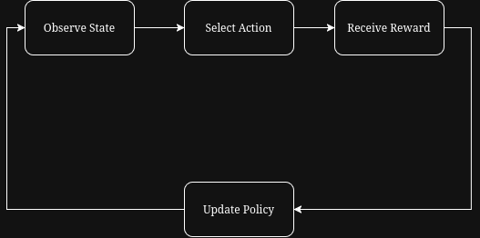

Over many episodes, the policy improves and learns which actions are most successful at keeping the pole balanced.

A2C
Advantage Actor-Critic combines policy-based and value-based reinforcement learning. It uses an actor to determine which action should be performed and a critic to evaluate how beneficial the current state is. For CartPole, the actor selects whether the cart should move left or right. The critic evaluates the result and helps determine whether the action performed better or worse than expected.
This difference is called the advantage and is used to improve the actor's policy. The critic is also updated so that its future estimates become more accurate. Having the critic provide feedback can reduce some of the variability associated with basic policy-gradient methods (Yoon, 2019).
A simplified A2C process is:
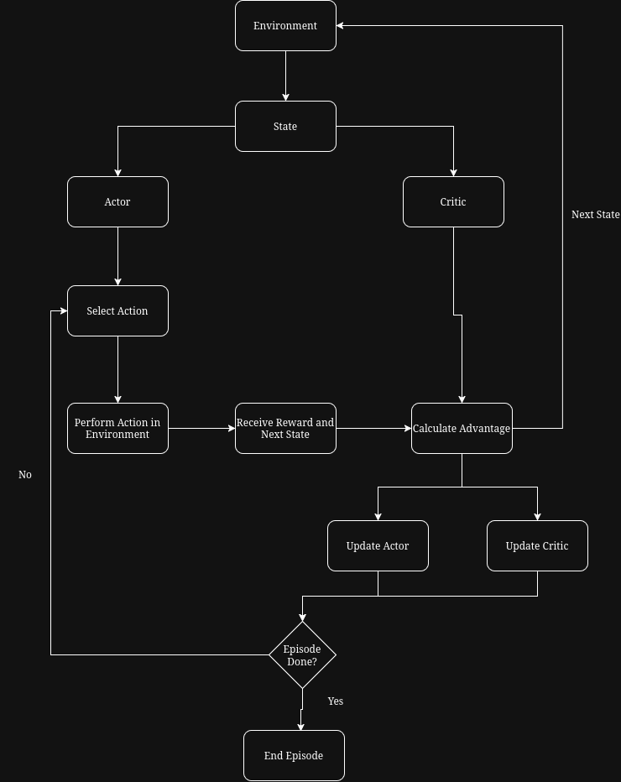

Policy Gradient vs. Value-Based Approaches
Policy-gradient algorithms differ from value-based approaches primarily in what they learn. REINFORCE directly learns a policy that determines the probability of selecting each action. Actions that produce greater rewards become more likely to be selected in the future (OpenAI, n.d.).
Q-learning instead learns the expected cumulative reward, or Q-value, for taking a particular action in a given state. In the DQN CartPole implementation, the neural network estimates Q-values for moving left and right, and the agent normally selects the action with the greatest value. Therefore, Deep Q-Network learns action values, while REINFORCE directly learns a policy for selecting actions.

Actor-Critic Approaches
Actor-critic approaches combine characteristics of both methods. The actor learns a policy similar to REINFORCE, while the critic learns a value function similar to value-based reinforcement learning. The critic then provides feedback that helps the actor improve its decisions.
All three approaches can solve CartPole but use different learning strategies. Deep Q-Network learns the values of actions, REINFORCE directly learns which actions should be selected, and Advantage Actor-Critic combines a learned policy with value estimates. This allows actor-critic methods to take advantage of ideas from both policy- and value-based reinforcement learning.

References
OpenAI. (n.d.). Vanilla policy gradient. Spinning Up in Deep RL. OpenAI Spinning Up
Yoon, C. (2018, December 30). Deriving policy gradients and implementing REINFORCE. Medium. Deriving Policy Gradients and Implementing REINFORCE
Yoon, C. (2019, February 5). Understanding actor critic methods and A2C. Towards Data Science.

